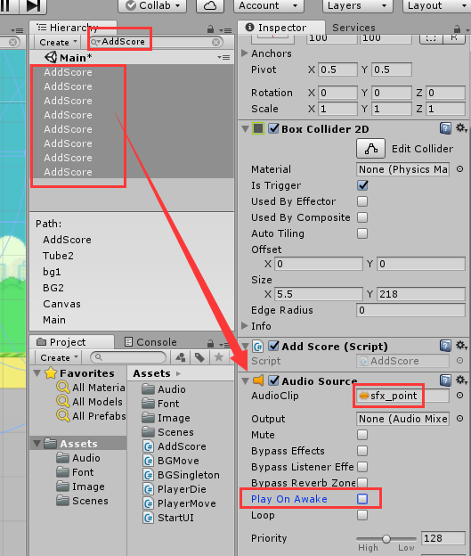

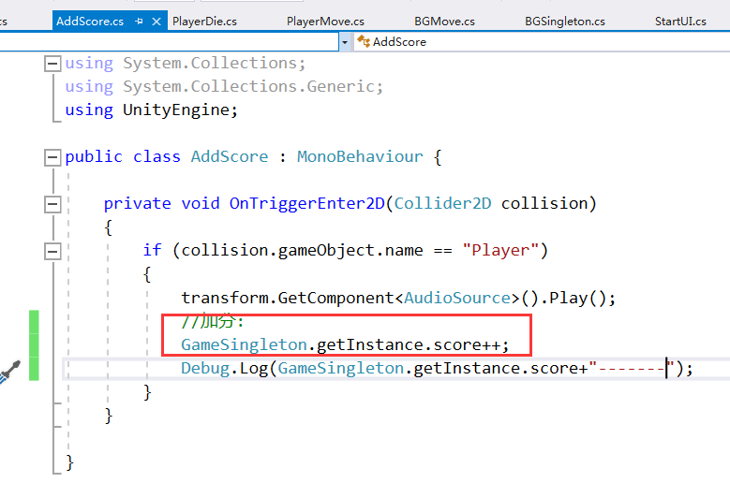

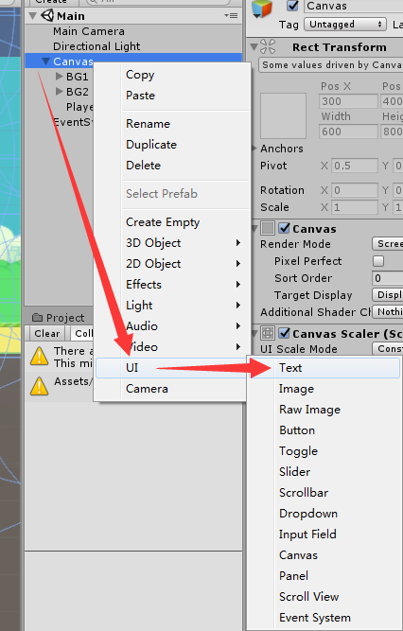

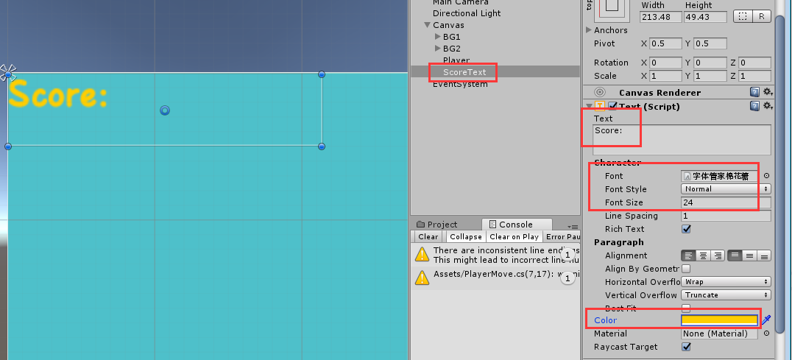

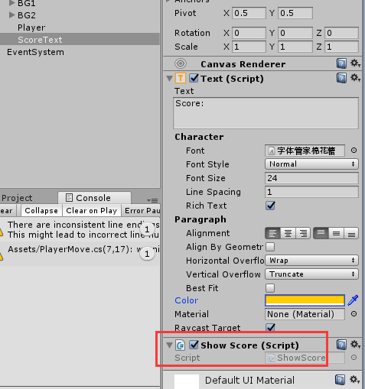

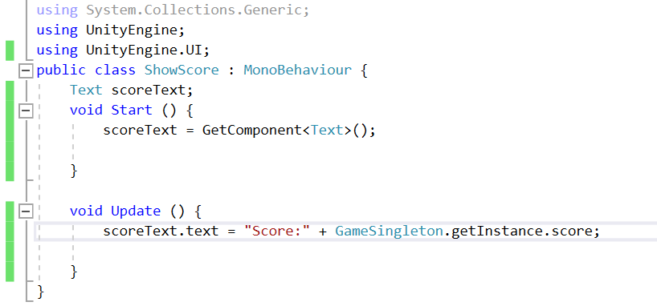

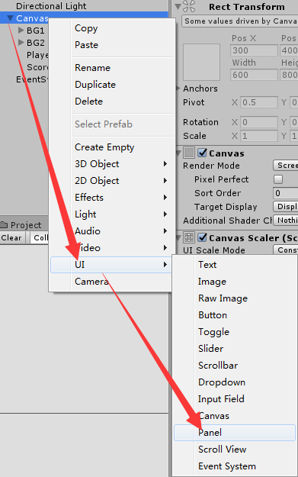

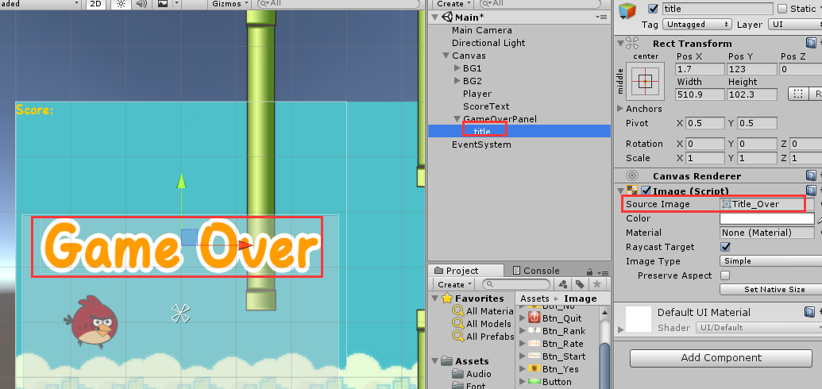

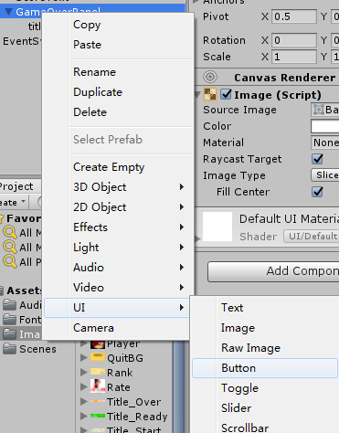

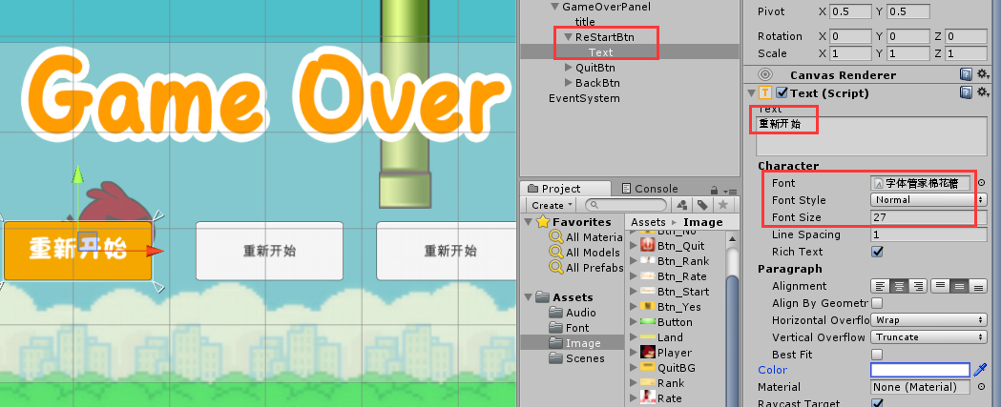

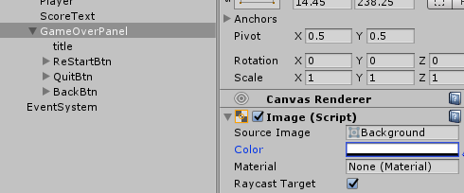



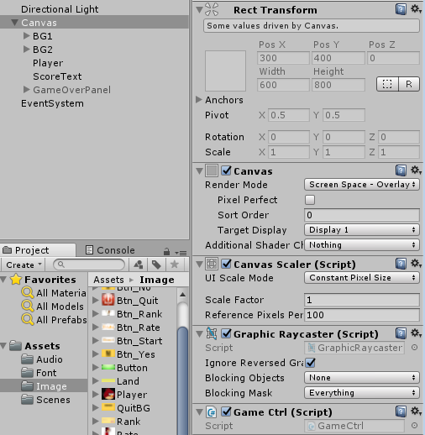

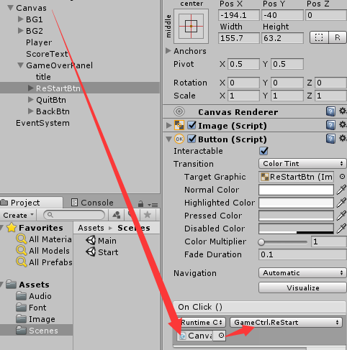

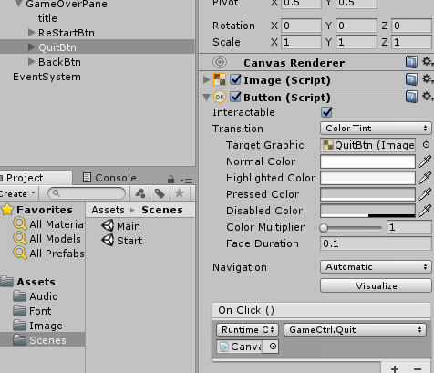

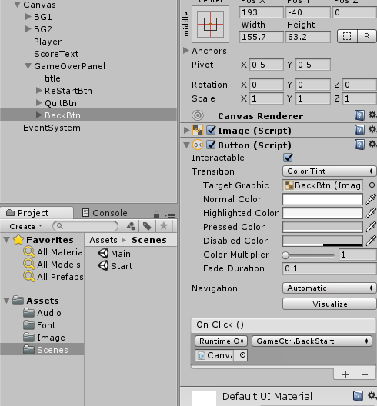

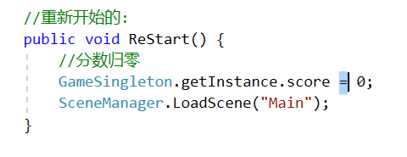

**代码：**

public class PlayerDie : MonoBehaviour

{

Transform gameover;

private void Start()

{

gameover = GameObject.Find("Canvas").transform.GetChild(4);

}

private void OnCollisionEnter2D(Collision2D collision)

{

if (collision.gameObject.name == "Player")

{

GetComponent<AudioSource>().Play();

//死亡界面出现

gameover.gameObject.SetActive(true);

//人物停止移动

Rigidbody2D rigi = GameObject.Find("Player").GetComponent<Rigidbody2D>();

Destroy(rigi);

//地图停止移动

BGMove bg1 = GameObject.Find("BG1").GetComponent<BGMove>();

BGMove bg2 = GameObject.Find("BG2").GetComponent<BGMove>();

//禁用脚本;

bg1.enabled = false;

bg2.enabled = false;

}

}

}

public class AddScore : MonoBehaviour

{

private void OnTriggerEnter2D(Collider2D collision)

{

if (collision.gameObject.name == "Player")

{

transform.GetComponent<AudioSource>().Play();

//加分:

GameSingleton.getInstance.score++;

}

}

}

public class GameSingleton

{

public float score;

public float bestScore;

//第二类：静态字段，保存类的实例

static GameSingleton instance;

//第一步私有构造

private GameSingleton(){}

//第三步：静态方法或属性

public static GameSingleton getInstance

{

get

{

if (instance == null)

{

instance = new GameSingleton();

}

return instance;

}

}

public void setBestScore()

{

if (score > bestScore)

{

bestScore = score;

}

}

}

using UnityEngine.UI;

public class ShowScore : MonoBehaviour

{

Text scoreText;

void Start()

{

scoreText = GetComponent<Text>();

}

void Update()

{

scoreText.text = "Score:" + GameSingleton.getInstance.score;

}

}

//场景管理的命名空间

using UnityEngine.SceneManagement;

public class GameCtrl : MonoBehaviour

{

//返回:

public void BackStart()

{

SceneManager.LoadScene("Start");

}

//退出:

public void Quit()

{

Application.Quit();

}

//重新开始的:

public void ReStart()

{

//分数归0

GameSingleton.getInstance.score = 0;

SceneManager.LoadScene("Main");

}

}

//管理命名空间

using UnityEngine.SceneManagement;

using UnityEngine.UI;

public class StartUi : MonoBehaviour

{

public GameObject startPanel; //开始

public GameObject ratePanel; //准备

public GameObject rankPanel; //排行

Text score;

Text best;

void Start()

{

score = rankPanel.transform.GetChild(1).GetChild(1).GetComponent<Text>();

best = rankPanel.transform.GetChild(1).GetChild(2).GetComponent<Text>();

}

private void Update()

{

score.text = GameSingleton.getInstance.score.ToString();

best.text = GameSingleton.getInstance.bestScore.ToString();

}

//打开准备界面。开始界面隐藏

public void ClickOpenRate()

{

//activeSelf：判断自身状态

if (!ratePanel.activeSelf)

{

ratePanel.SetActive(true);//激活

}

if (startPanel.activeSelf)

{

startPanel.SetActive(false);//未激活

}

}

//由准备返回开始

public void RateBackStart()

{

if (!startPanel.activeSelf)

{

startPanel.SetActive(true);//激活

}

if (ratePanel.activeSelf)

{

ratePanel.SetActive(false);//未激活

}

}

//由开始进入排行

public void ClickOpenRank()

{

//activeSelf：判断自身状态

if (!rankPanel.activeSelf)

{

rankPanel.SetActive(true);//激活

}

if (startPanel.activeSelf)

{

startPanel.SetActive(false);//未激活

}

}

//由排行返回开始

public void RankBackStart()

{

if (!startPanel.activeSelf)

{

startPanel.SetActive(true);//激活

}

if (rankPanel.activeSelf)

{

rankPanel.SetActive(false);//未激活

}

}

//开始

public void StartGame()

{

//分数归0

GameSingleton.getInstance.score = 0;

//加载场景,参数可以是场景名字，也可以是场景下标，但是前提是必须打包

SceneManager.LoadScene("Main");

}

//退出

public void QuitGame()

{

Application.Quit();//Application:应用程序，退出

}

}